PS | CA | 17-4.2 | Figures 1, 4, 5, 6, 8, 13 | te | In the PS, the AidsToNavigation feature type lists the attribute interoperabilityidentifier, but it is not mentioned in any of the other documents. | Remove the interoperabilityidentifier attribute from the AidsToNavigation feature type in the PS Figures 1, 4, 5, 6, 8 and 13. | Remove the attribute
PS | CA | 17-4.2 | Figures  1, 2, 7, 8 | te | In the PS, the GenericBuoy feature type lists the radarConspicuous attribute as a complex attribute, while the DCEG and FC for the same feature type has the radarConspicuous attribute as Boolean. | Resolve the discrepancy of the GenericBuoy feature type in the PS so that the attribute radarConspicuous is Boolean to match the DCEG and FC. | Change the attribute type as Boolean
PS | CA | 17-4.2 | Figure 10 | te | In the PS, the categoryOfFogSignal attribute has only four (4) enumerated values, while the XML, DCEG and FC lists ten (10) enumerated values. | Extend enumerated list for the categoryOfFogSignal attribute in the PS match what is in the XML, DCEG and FC. | Extend enumerated list to be consistent between PC, DCEG and FC.
PS  DCEG | CA | PS 17-4.2  DCEG 4.1, 4.2, 4.3, 4.4, 4.5 | PS Figure 11 | te | In the PS, the beaconShape attribute has only four (4) enumerated values, while the FC lists seven (7) enumerated values.  In the DCEG, the enumerated list for beaconShape is missing for the following feature types:  4.1 SpecialPurposeGeneralBeacon,  4.2 LateralBeacon,  4.3 CardinalBeacon,  4.4 IsolatedDangerBeacon,  4.5 SafeWaterBeacon | Extend the enumerated list for the beaconShape attribute in the PS to match what is in the FC.  Add the enumerated list to the beaconShape attribute to the DCEG to match the FC for the following feature types:  4.1 SpecialPurposeGeneralBeacon,  4.2 LateralBeacon,  4.3 CardinalBeacon,  4.4 IsolatedDangerBeacon,  4.5 SafeWaterBeacon | Extend enumerated list to be consistent between PC, DCEG and FC.  Add beacon shape attribute for the feature types in the DCEG  SpecialPurposeGeneralBeacon,  LateralBeacon,  CardinalBeacon,  IsolatedDangerBeacon,  SafeWaterBeacon
PS | CA | 17-4.2 | Figure 12 | te | The enumerated list for the status attribute in the PS does not reflect what is in the DCEG or the FC. | Remove the enumerated values “experimental = 43”, “temporarily discontinued = 44” and “temporarily relocated = 45” and extend the enumerated values in the PS Figure 12 to match what is in the DCEG and FC. | Update enumerated list for the status attribute
PS | CA | 17-4.2 | Figure 12 | te | The verticalDatum attribute has only one (1) enumerated value listed, while the DCEG and FC has a more extensive list. | Extend the enumerated list for the verticalDatum attribute in the PS to match what is in the DCEG and FC. | Update the vertical Datum attribute in the PS
PS | CA | 17-4.2 | Figure 12 | te | The visualProminence attribute has only two (2) enumerated values listed, while the DCEG and FC list three (3) values. | Add the missing enumerated value “prominent = 3” to the visualProminence attribute in the PS Figure 12 to match what is in the DCEG and FC. | Update the visual prominence attribute in the PS
FC | CA | 5.50 |  | te | In the FC, there are no definitions provided for the three (3) values listed under the categoryOfPhysicalAISAidToNavigation attribute. | Add definitions for the three (3) values listed under the categoryOfPhysicalAISAidToNavigation attribute in the FC. | Add definitions for the three attributes in the FC
PS | CHINA | 6.2 | Data Compliance and Integrity | te | (1)The content of S-158:100 describes general principles but lacks practical operability.  (2)According to S-100 Compliance,4 compliance levels for the S-100 product specification identified in S-100 Version 5.2.0. | (1)To develop S-158:201 correspondingly based on S-158:101;  (2) To declare an S-201 compliance category to facilitate a means of communicating the intent of a Product Specification and resulting products. | (1) After 2.0, S-201 validation will be developed  (2) For S-100 Compliance, Category 3 – IHO S-100 compliant with standard encoding
PS  DCEG | CHINA | PS 4.2  DCEG3.3.1.1 | Paragraph 2,etc | ed | The PS claims alignment with IHO S-57 and S-101 standards, however some substantive inconsistencies are identified. eg：  (1)Discrepancy in the 'Colour' attribute between "Safe water beacon" and "Emergency wreck marking buoy";  (2)In the “marks navigational – system of” attribute, the simultaneous presence of both “1 and 2 (IALA A and B)” and “1 or 2 (IALA A or B)” expressions exhibits non-uniform operator terminology, thereby demonstrating non-conformity with S-101 standards.  (3)Inconsistent attribute values for catspm.  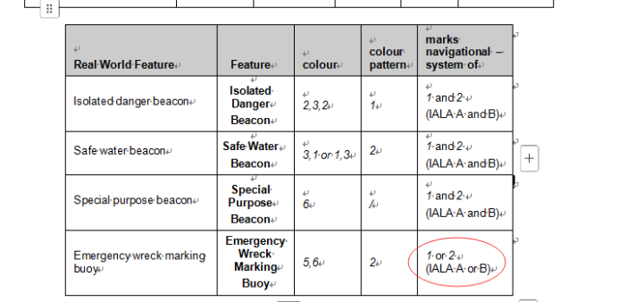  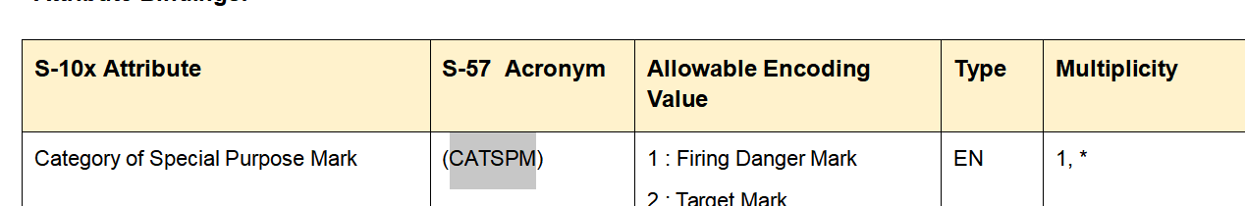 | Reorganize the document to make it consistent with IHO S-57 and S-101.  (1)Modify the "color" attribute of feature Emergency Wreck Marking Buoy to “5,6 or 6,5”;  (2)Modify the “marks navigational – system of” attribute from“1 or 2 (IALA A or B)”to“1 and 2 (IALA A and B)”。  (3)Remove Clause 64.  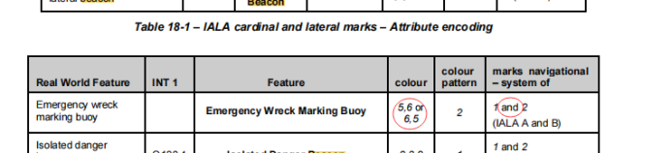  64 : Jetski Prohibited | (1) Modify the colour attribute  (2) Modify the “marks navigational – system of” attribute  (3) Remove the enumerated value (64)
DCEG | CHINA | 2.4.2 | Simple attribute types | ed | Simple Attributes are categorically bound to eight predefined data types, whereas extended feature types (e.g., URI) are visually represented in the main schema diagram and explicitly governed under Clause 5.102 of the specification."  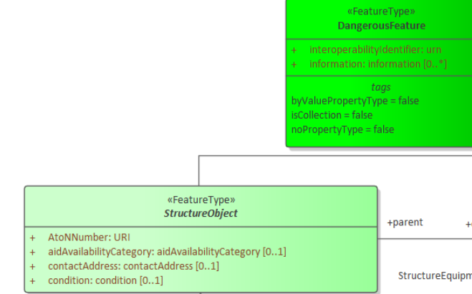 | Add URI to the feature types of DCEG attribute value and explain its connotation. | Add URI definition in the DCEG
PC | CHINA | 7.symbols | symbols | ed | The symbol of AISPHY is missing. | Add the symbols of AISPHY.etc | Add the symbol  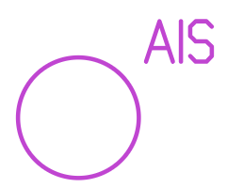
DCEG | CHINA | 1.5 | Paragraph 1 | ed | The clause 1.5.1 mentioned in clause 1.5 is not found in either the main document or Annex A.  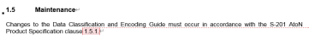 | Confirm whether the referenced 1.5.1 is clause 8 of the main document, and correct the reference if necessary. | Update the number as 1.4.1
DCEG | CHINA | 4.1 | Table | ed | The attribute "AtoN Number" appears twice in one table, with inconsistent attribute types, and both require the multiplicity to be enforced as 1,1.  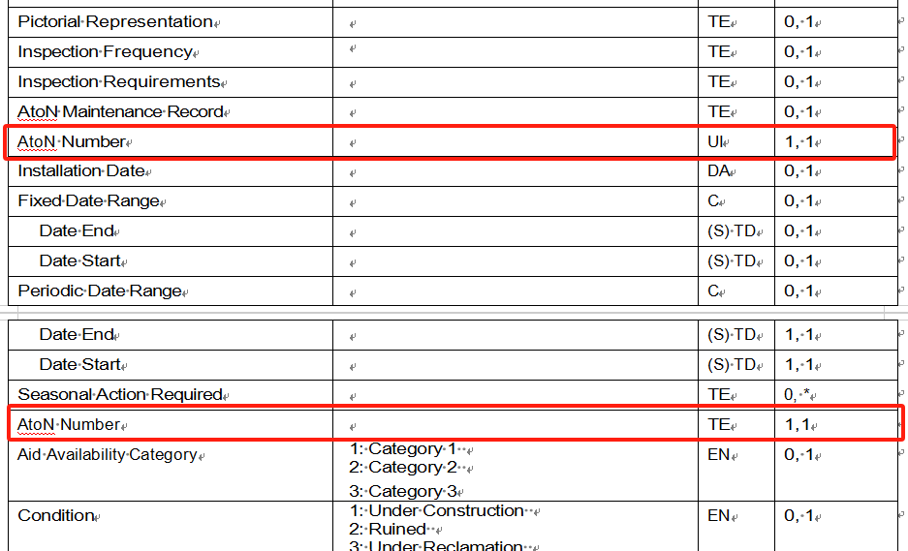 | Review and amend it. | Remove one of the two
PS | CHINA | 4.2 | Figure 11 | ed | In the diagram, the attribute values of the status "candidate for modification" and "experimental "are both 43, resulting in duplication.  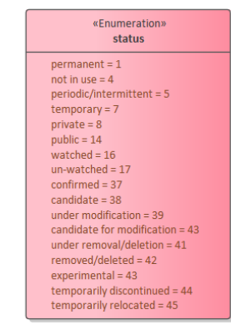 | Correct the attribute value of "candidate for modification" to "40". | Update the enumerated list
PS | CHINA | 4.2 | Figure 11  Figure 12 | ed | The listed information of the light characteristic is repeated in the two diagrams, and the contents are inconsistent.  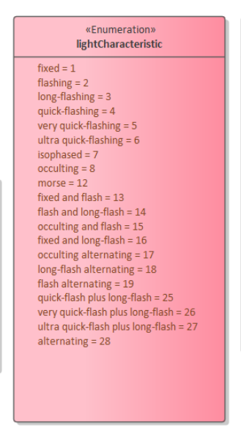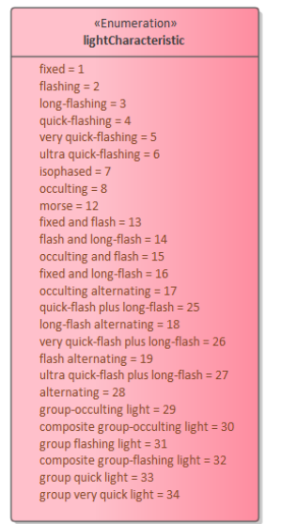 | Combine and unify the information. | Update the UML model
PS、DCEG | CHINA | 4.2，4.1 | Figure 11,etc | ed | There are several inconsistencies between the main document and Annex A, such as the descriptions of "buoyShape" and "BeaconShape".  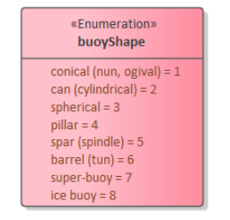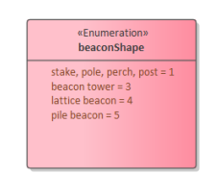 | Unify the expression of the main document and the annex.  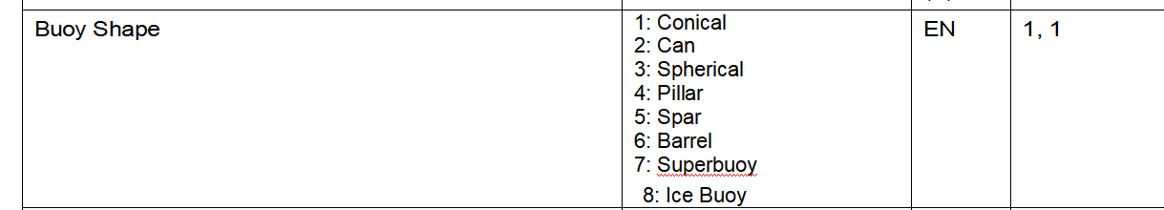 | Update the UML Model  Update the UML Model
DCEG | CHINA | 4.1,4.2，4.3，4.4，4.5，5.2，5.3，5.4，5.5,5.6,8.2,8.7 | Definition | ed | There are several references to definitions in the 5th edition of the UK publication, such as: A special purpose beacon is primarily used to indicate an area or feature, the nature of which is apparent from reference to a chart, Sailing Directions or Notices to Mariners. (UKHO NP 735, 5th Edition). | Do not include version information of the referenced individual country or regional documents in the product specification; if it is indeed necessary, it can be explained by a note. | Remove the references of individual country or regional documents.
PS | CHINA | 4.2 | Figure 1 | ed | Attributes such as "vertical length" and "vertical accuracy" are involved in featuretype, without explanations.  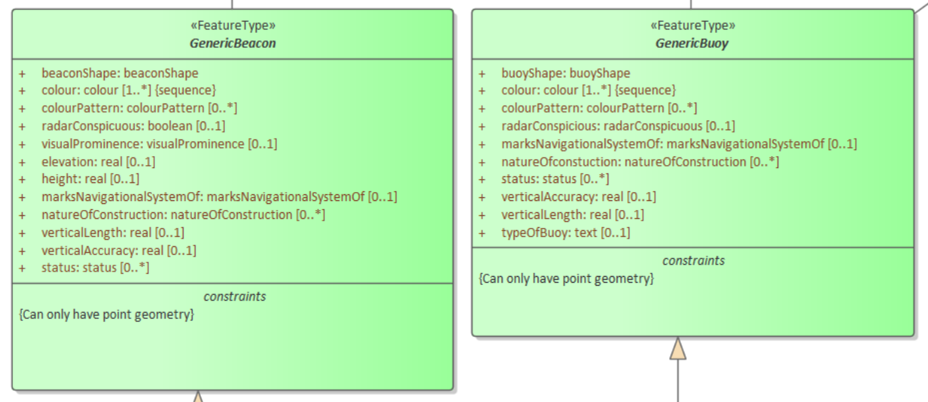 | Add explanations of terms and guidelines. | Vertical length definition included,  Vertical accuracy will be proposed to GI registry with definition.
 | UK | Annex A | Many | GE | Many definitions contain fields called “Fixed Date Range” and “Periodic Date Range”, but there is no description as to what information should be filled here. They are date fields, but what do the dates represent? | Clarify the purpose of the fields. Unable to propose alternative text until the purpose of the fields has been clarified. | To align with S-101, this attribute was included.
 | UK | Annex A | 8.2, 8.3 | TE | In these tables, fields contain “Colour” and “Height”, but it is unclear for what element of the AtoN the colour and height is needed. Is it the light, the structure, or something else? | Clarify what information should be placed in these fields. | To align with S-101, this attribute was included.  The colour and height attributes mean the one of light
 | UK | Annex A | 8.2, 8.3 | TE | The tables contain a field called “Vertical Length”, but it is unclear how this is different to the “Height” field. | Clarify what information should be placed in this field. | Refer to the page 14 in DCEG
 | UK | Annex A | 8.2, 8.3 | ED | The tables contain a field called “Candela”. However, the main document suggests that fields for intensity are “Peak Intensity” and “Effective Intensity”. | Correct Annex to include “Effective Intensity” and “Peak Intensity” fields, and remove the “Candela” field. | Include Effective intensity and peak intensity, remove the candela attribute
 | UK | Annex A | 8.2, 8.3 | TE | For the field “Exhibition Condition of Light”, the list of potential values should contain an option for “Fog and Night Light”. These are lights that are normally lit during the night, but will also come on when it is foggy. | Either add “Fog and Night Light” or allow multiple values for this field. | Allow multiple values for Exhibition Condition of Light attribute
 | UK | Annex A | 8.3 | ED | The field “Exhibition Condition of Light” does not contain the list of valid values as seen in table 8.2. | Add valid values for this field. | Add values
 | UK | Annex A | 8.3 | TE | The fields for “Geographical Range” and “Luminous Range” are potentially meaningless without additional information or standardised conditions to calculate the values in these fields. For example, the geographical range is dependant on the height of the observer (i.e. the mariner), and the luminous range is dependent on several factors. | Remove these fields. | Remove the attributes
 | UK | Annex A | 8.3 | GE | It is unclear why a differentiation is being made between a sectored light and an omni-directional light (“LightAllAround”). An omni-directional light can be considered as a sectored light with an arc of 360 degrees. In that respect, it would allow the data structure to be simplified if all lights were considered in that way. | Remove “LightsAllAround”, adding clarifying text to say that the Sectored light field can be used for omni-directional lights with a sector width of 360 degrees. | To align with S-101 ENC, the feature should be kept
 | UK | Annex A | 8.2 | TE | The field for the light colour is potentially misleading due to the only valid IALA colours being White, Red, Green (A and B), Yellow and Blue (plus Black for a blank arc). However, older lights will have potentially different IALA light colour names. For example, lights installed between 2008 and 2017 could have light colours in the “temporary” colour regions (e.g. “Red Temporary”). | Update the allowable list to be:  White  Red  Green A  Green B  Yellow  Blue  White Temporary  Red Temporary  Yellow Temporary  Green Preferred  Green Temporary | Update the list
 | UK | Annex A | 8.3 | TE | This table does not contain a field to include colour of the light. If the field “Colour” is intended for this purpose, then that needs to be clarified in the document. | Either clarify how light colour should be included, or add a field called “Light Colour”, using the colour list in the row above. | Update the colour list
 | UK | Annex A | 8.2, 8.3 | TE | There is no field that contains information about the vertical divergence of the light. | Add a field called vertical divergence. This should be a real value and the unit is degrees. | Add vertical divergence as new attribute
 | UK | Annex A | 8.3 | ED | The enumerations in the table are incomplete. | Add all valid values to the appropriate fields (e.g. Category of Light, Exhibition Condition of Light, etc.). | Update the enumeration
 | UK | Annex A | 8.4 | ED | The definition is a repeat of the LightAllAround data structure. | Add correct definition of the data structure. | Add correct definition
 | DK |  |  | te | The association ‘ShackleToSwivelConnection’ is defined with the two roles ‘shackleToSwivelconnected’ and ‘shackleToSwivelconnectedTo’ but is used with the role ‘shackleToBridleconnecteda’ on the feature ‘Swivel’. | The role defined on the feature ‘Swivel’ for the binding should be renamed to ‘shackleToSwivelconnected’. | Update the data model and FC
 | DK |  |  | te | In the association ‘Atonstatus’ the role ‘Atonpart’ isn’t referenced anywhere. | Either remove the unused role or add a binding using the role. | Remove the unused role in the data model
 | DK |  |  | te | In the association ‘AtonFixingMethodAssociation’ the role ‘fixedBy’ isn’t referenced anywhere. | Either remove the unused role or add a binding using the role. | Remove the unused role in the data model
 | DK |  |  | te | In the association ‘AtonPositioningInformationAssociation’ the role ‘positionedBy’ isn’t referenced anywhere. | Either remove the unused role or add a binding using the role. | Remove the unused role in the data model
 | DK |  |  | te | In the association ‘ShackleConnectionFromCable’ the role ‘shackleToCableconnectedTo’ isn’t referenced anywhere. | Either remove the unused role or add a binding using the role. | Remove the unused role in the data model
 | DK |  |  | te | The definition on a lot of roles are defined as ‘TBD’ or ‘-‘. | A telling definition should be applied or an empty string. TBD in a operational product specification looks a bit strange. | The missing definition included
DCEG | SE | 7.1-7.3 | Geometric primitives | Ed. | According to DCEG, the three types of AIS Aids to Navigation have curve and surface as an allowable geometric primitive but in the FC, they can only be points. FC seems to be correct and DCEG should be corrected. | Remove curve and surface from allowable primitives | Remove curve and surface for allowable primitives
FC | SE | Simple attribute lightCharacteristic |  | Te | Simple attribute lightCharacteristic has values 9-11 as allowable attributes. According to existing IALA guidelines, Interrupted Quick, Interrupted Very Quick and Interrupted Ultra Quick should not be used. | Remove allowable values 9-11 for lightCharacteristic | Remove allowable values
DCEG | SE | 8.2-8.5 |  | Te | Simple attribute lightCharacteristic has values 9-11 as allowable attributes. According to existing IALA guidelines, Interrupted Quick, Interrupted Very Quick and Interrupted Ultra Quick should not be used. | Remove allowable values 9-11 for lightCharacteristic in DCEG as per previous comment. | Remove allowable values
FC & DCEG | SE | DCEG 8.2-8.5 |  | Te | The Super Type GenericLight have a binding to the complex attribute RhythmOfLight. For this reason, RhythmOfLight is inherited to the LightSector feature. For the sectorCharacteristics complex attribute, lightCharacteristics can be encoded but not signalGroup, signalPeriod, signalSequence and candela.  This causes two issues:  - It is possible to encode lightCharacteristics as part of the complex attribute RhythmOfLight and, at the same time, on in the sectorCharacteristics complex attribute. This is an unnecessary source for misunderstanding and double encoding.  - signalGroup, signalPeriod, signalSequence and candela cannot be encoded if the light have different values on different sectors.  It also creates a deviation from S-101 which will complicate mapping between the standards. | - Remove RhythmOfLight from GenericLight  - Add RhythmOfLight on LightAllAround, LightAirObstruction and LightFogDetector  Add signalGroup, signalPeriod, signalSequence and candela to the sectorCharacteristics complex attribute | Move the location of Rhythm of light  Add RhythmOfLight on LightAllAround, LightAirObstruction and LightFogDetector
FC & DCEG | SE | 8.7 |  | Te | For logical reasons, the light reflected from a retroreflector cannot be black. | Remove black from the allowable attribute of colour for RetroReflector | Remove black colour
DCEG | SE | 8.9 |  | Te | Everything in this section is copied over from the previous section about radar reflectors | Update the section to be correct. | Update the section
PS, main document | FTIA | 4.2 | Figures 10, 11 and 12 | ed | Enumeratios in UML not aligned with FC, e.g. use of uppercase letters, values missing and include values not available in Data Dictionary Register | Align with FC | Align with FC
Annex A, DCEG | FTIA |  |  | ed | Several references to other documentation missing. Marked with “see clause XX” | Update or remove references | Update the sentences.
Annex A, DCEG | FTIA | 3.3 |  | ge | Text states that IALA MBS details can be found in “other publications (e.g. UK’s booklet NP 735 “IALA Maritime Buoyage System”)”. | Propose to change to refer IALA’s documentation:  “The IALA Maritime Buoyage System details, including the extent of Regions A and B, are given in IALA recommendation R1001 The IALA Maritime Buoyage System (MBS). | Change the reference.
Annex A, DCEG | FTIA | 3.3. |  | ge | Text states that “Five types of marks are provided by the system: Lateral, Cardinal, Isolated danger, Safe water and Special marks, which may be used in any combination. Emergency Wreck Marking Buoys were added on a trial basis in 2006.”  Emergency Wreck Marking Buoys are included in the current version of MBS | Propose to change to:  “Within the MBS, there are six types of marks, which may be used alone or in combination:  Lateral, Cardinal, Isolated danger, Safe water, Special marks and Emergency Wreck Marks” | Change the paragraph
Annex A, DCEG | FTIA | 4.1 |  | ed | Allowable Encoding Values for Category of special purpose mark not aligned with FC, (use of uppercase letters, values missing). | Align with FC | Update the DCEG
Annex A, DCEG | FTIA | 4.2, 5.2 |  | ed | Allowable Encoding Values for Category of lateral mark not aligned with FC, (use of uppercase letters, values missing). | Align with FC | Update the DCEG
Annex A, DCEG | FTIA | 4.3, 5.3 |  | ed | Allowable Encoding Values for Category of cardinal mark not aligned with FC (use of uppercase letters) | Align with FC | Update the DCEG
Annex A, DCEG | FTIA | 4 - 7 |  | ed | Several features have “AtoN Number” -attribute twice, as type TE and UI | Remove AtoN Number attributes with type TE | Remove one of the two
Annex A, DCEG | FTIA | 2.4 and 2.4.2 |  | ge | Definition for type UI missing | Add definition for UI e.g. Uniform Resource Identifier (URI) is a unique sequence of characters that identifies an abstract or physical resource.  Update the number of types in 2.4.2 to “Each simple attribute is assigned to one of 10 types:” | Add the definition.  Update the number of types
Annex A, DCEG | FTIA | 8 |  | ed | During ARM 20 “AtoN Number”-attribute was changed to be part of structure object. In DCEG all equipment features still have AtoN Number | Remove AtoN Number-attribute from equipment feature types | Remove Aton Number from equipment feature types
Annex A, DCEG | FTIA | 8.2, 8.3, 8.4, 8.5. |  | ed | Light features have “candela” -attribute. Changed during ARM20 to be replaced with Effective Intensity and Peak Intensity | Delete candela -attribute from Light equipment.  Add Effective Intensity and Peak Intensity attributes | Delete candela
Annex C, FC | FTIA | 2.4. |  | ed | CamelCase for Electronic Aton is EquipmentAton | Change CamelCase to ElectronicAton | Change the camel case
Annex B, schema | FTIA |  |  | ge | “LightSectored” -feature missing “valueOfGeographicRange”,  ”valueOfLuminousRange” -attributes | Add attributes to lightSector | From the comments of UK, the attributes were removed.
Annex B,  Annex C | FTIA |  |  | ed | Enumerations for  ShackleTypeType,  ChangeTypesType,  CategoryOfPowerSourceType and  CategoryOfAggregationType have space in the end  i.e. "Advanced notice of changes " | Remove space | Remove space
Annex B | FTIA |  |  | ge | AIS AtoN’s (virtual, synthetic, physical) have “…AISbroadcasts” -element as mandatory, Radio station that broadcasts AIS information is not known in all cases. | Change “virtualAISbroadcasts”, “physicalAISbroadcast” and “syntheticAISbroadcasts” to optional | Change those to optional
Annex B | FTIA |  |  | ge | VirtualAISAidToNavigation have “virtualAISbroadcasts” -element as maxOccurs=”1” and RadioStation have “virtualAISbroadcastBy” and ”physicalAISbroadcastBy” -elements as maxOccurs=”1”  Information on one virtual AIS AtoN can be broadcasted by several AIS-basestations (Radio station) and vice versa one AIS-basestation can broadcast information on several virtual or synthetic AIS AtoN’s | Change “virtualAISbroadcasts”, virtualAISbroadcastBy and ”physicalAISbroadcastBy” to allow multiple values (maxOccurs="unbounded") | Change those to allow multiple values
Annex B | FTIA |  |  | ge | AIS AtoN’s can have AtoN Number, but as “AtoNNumber”-attribute was moved to StructureObject the current data model does not allow AIS AtoN’s to have AtoN Number | Add “AtoNNumber” -attribute to “ElectronicAtoN” -feature as optional. | Add AtoNNumber attribute as optional
FC | FTIA |  |  | ge | Category of installation buoy missing from FC, can be found in DCEG | Add Category of installation buoy to FC | Add the attribute to FC
FC | TC |  |  | ge | Testing of the latest changes in the PS was not possible before 23.4 due to the time needed by developers to make the discussed changes in the FC- file. Therefore most testing was conducted on the file provided before ARM- meeting. Testing of up-to-date XSD- file was not possible. | Provide enough time for developers to finalize the machine-readable files after changes are suggested. Even small changes usually affect multiple parts of the PS and changes need time. Machine readable documents are needed for thorough testing. | Comment
FC | TC |  |  | ge | AtonAssociation is used to associate two or more aids to navigation and/or navigationally relevant features. Category can be 1=channel markings or 2=danger markings. If use case if developing List of Light, and Atons are grouped by fairway, area etc. as recommended in S-12 it seems that the AtonAssociation (or AtonAggregation) must be used to group AidsToNavigation, but additional data of the "group" is only available within a DengerousFeature - object. | Consider renaming DangerousFeature to a more generic type name, which can provide additional information to any kind of AtonAssociation. | After 2.0, need to discuss the name
FC | TC |  |  | ge | In some versions of the FC, the Feature 'Light' was present alongside LightAllAround and LIghtSectored | Consider whether Light is still needed alongside LightAllAround and LightSectored and consider removal if still present. | Withdrawn comment after checking new FC.
FC | TC |  |  | te | In newest FC (23.4.2025) SyntethicAIS still has Equipment as Supertype. | Check Supertypes for all AIS- features and correct as needed to ElectronicAton | Update FC
FC | TC |  |  | te | In newest FC (23.4.2025), referenced featuretype seem wrong in DangerousFeatureAssocitaion. | Check and modify FC lines:  15851 ref: DangerousFeature => AtonAssociation  15909 ref: AtonAssociation => DangerousFeature | Update FC
FC | TC |  |  | te | In newest FC (23.4.2025),positioningMethod is both a complex attribute and a role. Casing differs, but complexAttribute should not have capital first letter. | Consider renaming such, that complex attribute does not need capital first letter. | Update FC
3. S-201 DCEG - Annex A.doc | Irish Lights | Sections 4 through 7 | Table of S-201 meta and geo features | ge | In each subsection the table contains the Attribute “Aton Number” twice, with different Type. | Request clarification on correct Aton Number definition and remove duplicate. | Remove one of the two
Portrayal catalogue, symbols | NCA |  | Symbols in portrayal catalogue | GE | Color filled symbols in S-101  During the work with S-101 we have made a change and colorfilled symbols for floating AtoN is now allowed.  Will these be available or adopted into the S-201 portrayal catalogue?  I suggest that the portrayal catalogue in S-201 is equal to the portrayal catalogue in S-101, or at least include these as a starting point now.  All the symbols are found in the portrayal register at IHO. | https://registry.iho.int/portrayal/list.do  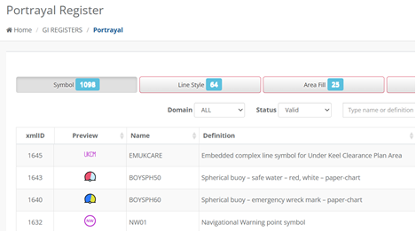 | Update the S-201 portrayal catalogue based on S-101 portrayal catalogue  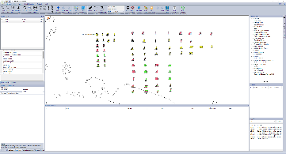
PS/  DCEG | NCA |  | PS 3, | ge | Coding of AtoN types with AIS message#21  NCA propose to use same table and indicator as in ITU-standard 1371-5. Same table/codes to be used for physical AIS, virtual AIS and synthetic AIS. In total there is 32 codes.  The term new danger marking should not be encoded, (PS figure 3 and others) as the EWMB should be used or any other regular marks (lateral, cardinal etc.) |  | Virtual AIS Aid to Navigation Type  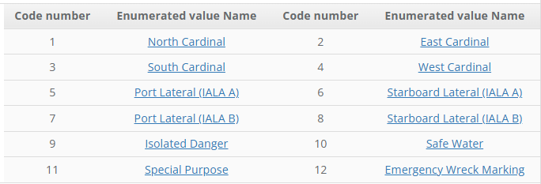  Category of Physical AIS Aid To Navigation  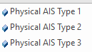  Category Of Synthetic AIS Aid to Navigation  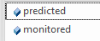  After 2.0, this topic will be discussed.
DCEG | NCA |  | DCEG para 5.6.1 | ge | In the table of use cases for special buoy, the EWMB is listed, this is not correct as EWMB is a separate mark.  The option for use as floating fish aggregating device should be deleted, propose to alter it to Marine Farm, which is missing in the list.  NCA wants to avoid having fish-nets marked as “floating fish aggregating device” |  | Update the table
DCEG | NCA |  | 7.1, 7.2, 7.3 | ge | AIS AtoN, coding of AIS AtoN should follow table from ITU (as shown above)  Types of AIS AtoN to be included in 7.2 and 7.3
DCEG | NCA |  | 8.2 | ge | Light sectored  NCA wants to confirm that changes in S-101 portrayal of sector lights are included, that each sector line has a option to code it with a separate value (in S-57 these are all set to nominal range of the light) |  | 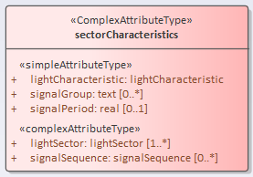  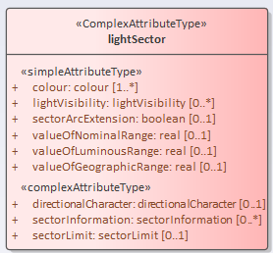
FC | NCA |  | 2.21, 2.51, 2.53, 5.56, | ge | Fish aggregating device (code 59), this code could be used by fishermen to mark fish-nets. This could trigger clutter on ECDIS display, these devices should be marked with AMRD type B equipment. | Propose to delete this code in the table. Could these devices alternatively be marked as Marine Farm? | Category of Special Purpose Mark  To align with S-101, retain the code.  After 2.0, this topic will be discussed.

